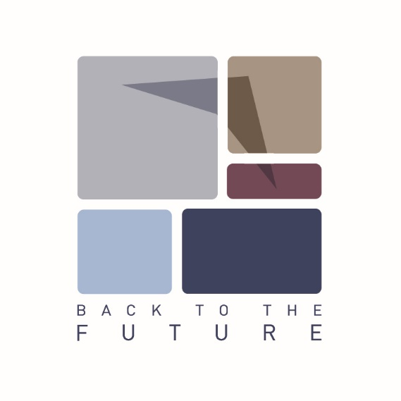

Registration form for international youth exchange

‘‘Back to the Future: European Citizenship through History‘‘
Lithuania, 2015 August 1-8

Full Name:

Date of Birth:

Gender: Male / Female

Contact information (e-mail/tel./address):

Special needs (vegetarian, allergy and etc.):

Why do you want to take part in the Youth Exchange "Back to the Future: European Citizenship through History"?

What is your knowledge about European History and Citizenship?

Do you have intercultural experience? If yes, what kind of?

Other information you would like to mention?

Would you have the opportunity to go to preparation meeting on 2015 June 25-28? (100% travel costs would be covered)
YES/NO

I agree to pay 30% of my travel costs.

Date, place:
Name:
Please send the filled form to intercambios@a-spin.pt until the 5th of May

