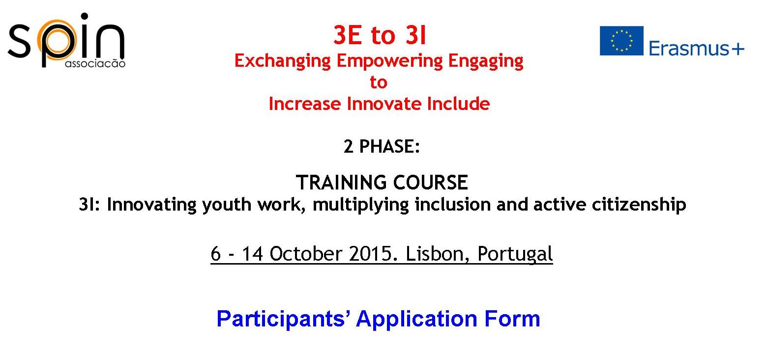
Attach  your  photo  here! |  | Name
 |  | Surname
 |  | Sex
Place and
Date of Birth
 |  | Address
 |  | Nationality
 |  | Telephone
 |  | E-mail
 |  | Skype
 |  | ID Card / Passport No.
 |  | Expiration date
Please, fill all the boxes!
Few words about your academic background.
Few words about your profession and/or your volunteering activities.
Do you have any experience in one or some of the topics covered by this training?
Have you ever participated in a similar course (Youth in action training courses or other non formal education programmes)? If yes, please provide some details.
Do you think is there any relation between inclusion and active citizenship? Please share your thoughts on this regard.
What could be your contribution for the success of the Training course?
Please, tell us one of your favourites famous quotes!
Which are your hobbies?
SPECIAL NEEDS: Do you have any allergies, diet restrictions, disabilities or disease which we should be aware of in order to be able to provide you the best work conditions?
Emergency Contact
Name
Relationship
Address
E-mail
Telephone
Thank you!
We are waiting for you in Lisbon!

