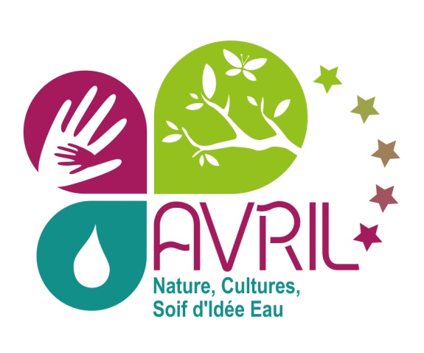

QUESTIONNAIRE FOR EVS CANDIDATES TO PROJECT 2013-FR-142
Short term EVS

Last Name:

First name:

City: Country:

Mother tongue:

Phone Numbers (with international dialling codes+prefixes):

Sending organisation’s name: Associação Spin para o Intercâmbio, Formação e Cooperação entre os Povos

E-mail address :

Skype name:

Emergency contact (name, e-mail, phone):

Please answer briefly

- Why did you choose France as a hosting country for your EVS experience?
_________________________________________________________________________________
____________________________________________________________________________________________________________________________________________________________________________________________________________________________________________________________________________________________________________________________________

- Which aspects of the project do you think were determinant for your choice of our project for your EVS? What do you find interesting in this project? What are your expectations?
_____________________________________________________________________________________________________________________________________________________________________________________________________________________________________________________________________________________________________________________________________________________________________________________________________________________

- Have you been a volunteer before in your local community or somewhere else? If yes, explain what you did. If not, explain us why would you like to make this step.
_____________________________________________________________________________________________________________________________________________________________________________________________________________________________________________________________________________________________________________________________________________________________________________________________________________________

- Have you ever participated in any of European Programme (Erasmus, Leonardo, Socrates, Youth, etc)?
__________________________________________________________________________________________________________________________________________________________________

- Have you ever been living abroad?
__________________________________________________________________________________________________________________________________________________________________

- Do you have any special needs (health care, dietary needs, allergy)?
___________________________________________________________________________________________________________________________________________________________________________________________________________________________________________________

- Have you ever worked before on nature protection? Do you feel motivated enough to develop this kind of activity?
_____________________________________________________________________________________________________________________________________________________________________________________________________________________________________________________________________________________________________________________________________________________________________________________________________________________

- This project is developed in mainly outdoor activities and sometimes it could be cold and rainy. How do think you would manage?
___________________________________________________________________________________________________________________________________________________________________________________________________________________________________________________
- The outdoor activity can be physically hard and dirty. How you will manage it?
___________________________________________________________________________________________________________________________________________________________________________________________________________________________________________________

- Do you have some knowledge or experience about handcraft or manual and creative activities? If yes, please describe briefly.
___________________________________________________________________________________________________________________________________________________________________________________________________________________________________________________

- Have you ever work before with children?
___________________________________________________________________________________________________________________________________________________________________________________________________________________________________________________

- Which are your strong and weak points?
___________________________________________________________________________________________________________________________________________________________________________________________________________________________________________________

- Which of your abilities do you consider important for the project and how could be your contribution?
___________________________________________________________________________________________________________________________________________________________________________________________________________________________________________________

- What would you like to learn from this project?
___________________________________________________________________________________________________________________________________________________________________________________________________________________________________________________

- Which kind of support would you need from this project?
___________________________________________________________________________________________________________________________________________________________________________________________________________________________________________________

- What kind of responsibilities do you think you could have during the activities of the project? Are you punctual? Are you responsible concerning the materials (working tools, cameras, and laptop)? Are you responsible during using dangerous tools (chainsaw, machete…..etc)?
____________________________________________________________________________________________________________________________________________________________________________________________________________________________________________________________________________________________________________________________________

- How do you think your integration in the project’s community would be?
___________________________________________________________________________________________________________________________________________________________________________________________________________________________________________________
- You will have to share your room with another volunteer. Is it disturbing you?
___________________________________________________________________________________________________________________________________________________________________________________________________________________________________________________

- Do you have some experience to live with other people and to share an apartment? If yes, how was it? Did you like it? If no, how you could handle to live with others?
___________________________________________________________________________________________________________________________________________________________________________________________________________________________________________________

- Do you have driving licence?
_________________________________________________________________________________

- Describe the training before departure that your sending organisation will provide you as an evs volunteer (ask your sending organization):
_____________________________________________________________________________________________________________________________________________________________________________________________________________________________________________________________________________________________________________________________________________________________________________________________________________________

Please send us your answer to the E-Mail address below
Thank You for your interest!

Association AVRIL
international@associationavril.org
www.associationavril.org
Tel: 00 33 233 19 00 35 Fax: 00 33 233 19 00 36

