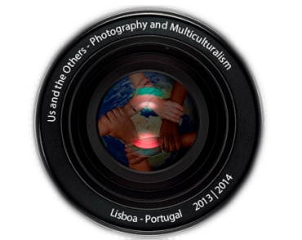
Training course
Us and the Others
Photography and Multiculturalism
Lisbon, 21-27 April 2014

APPLICATION FORM

Name |  |  | Surname
Date of Birth: | Place of Birth: |  |  |  | Nationality:
Address:
Email: |  |  |  | Tel:
Few words about your academic background:

Few words about your profession and/or your current activities:

Do you have any experience in one or some of the topics covered by this course?

Which are your main reasons for participating in this training course?

What you would like to gain from this training course?

SPECIAL NEEDS: Do you have any allergies, diet restrictions, disabilities or disease which we should be aware of in order to be able to provide you the best work conditions?
Course fee (€250) to be transferred to NIB: 0007.0000.00168350097.23
Date of payment: _____/____/_____ Please attach the proof of payment
Place and date |  | Signature
- Send application form back to: intercambios@a-spin.pt
- Deadline to receive application: 15th April 2014
NB: The course fee of €250 includes: tuition and course materials, lunch and coffee-breaks during the training days. You should bring your own photo camera. Any camera is accepted.

