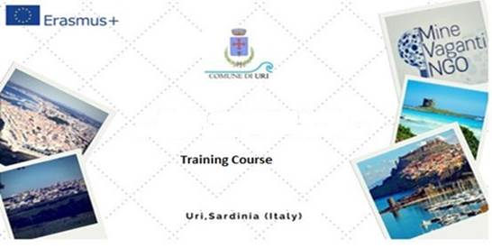

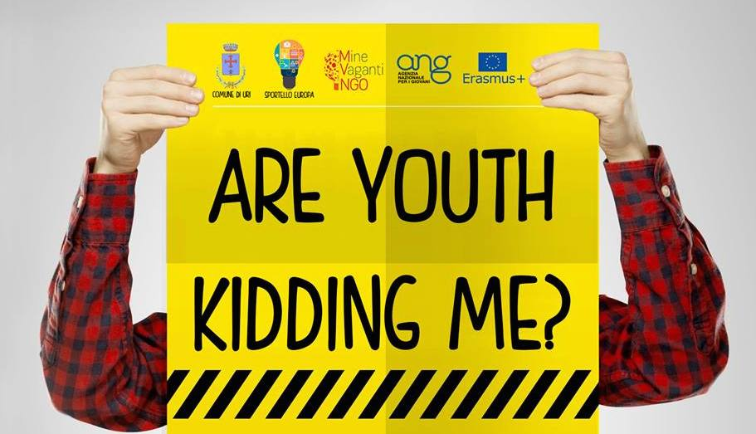

KA1 Erasmus Plus (Multiactivity)

Official Infopack

“Are youth Kidding me?”

25 February- 4 March 2016

Activity n.2

“THE LANGUAGE OF SATIRE: POTENTIALITIES AND MISUSE. RULES OF ENGAGEMENT FOR AN INCLUSIVE COMMUNICATION”

Training Course

PLACE AND DATE: Uri, Sardinia (Italy) 25 February -4, March 2016 (Travel Day included)

PARTICIPANTS: Youth workers involved in the fields of communication and dissemination.

COUNTRIES: Bulgaria , Italy, Portugal, Greece, Spain, Croatia
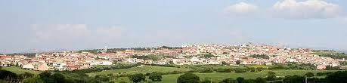
LANGUAGE: The working language will be English

The Municipality of Uri has the pleasure to promote a Training Course which will empower youth leaders with tools to master satire as a method for transmitting values and ideas. The objectives of the project will sensitize participants on the themes of non discriminatory speech and inclusive communication. The full picture of the event is to stage the ground for an encounter between different cultural sensibilities on the issue with youths as the central actors of exchange and mediation.

It is important to underline that the EU grant is half than usual according to Erasmus+ Programme rules when the applicant is a public body.
The attendance fee per participant is 30 Euro.

ACTIVITIES AND METHODS

The activities will be coordinated through non formal education methods (as group work andactivities, presentations, workshops and personal assignments, meetings with trainers, experts etc). During some activities participants will explore the specific issues, reflecting methods and its impacts and simulation excercises for skills development.

ORGANIZERS AND FACILITATORS
The main organizers and facilitators will be the “Youth Division” of Mine Vaganti NGO composed by, Mattia Cordioli, Claudia Baltolu and Jure Sterman.

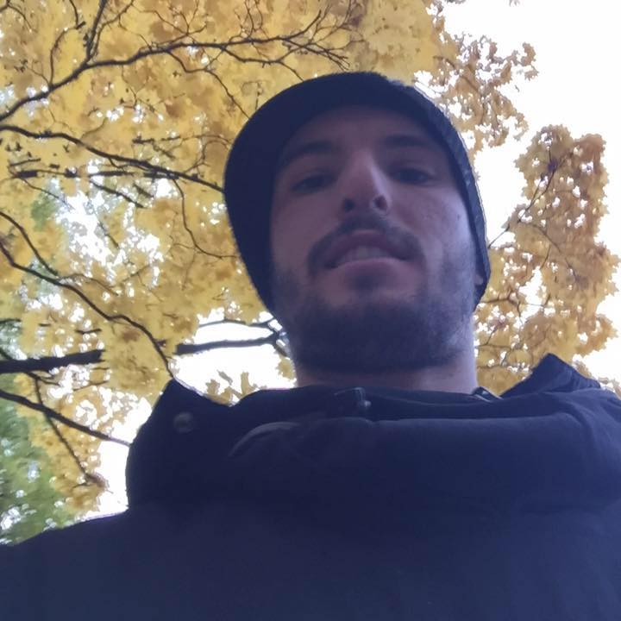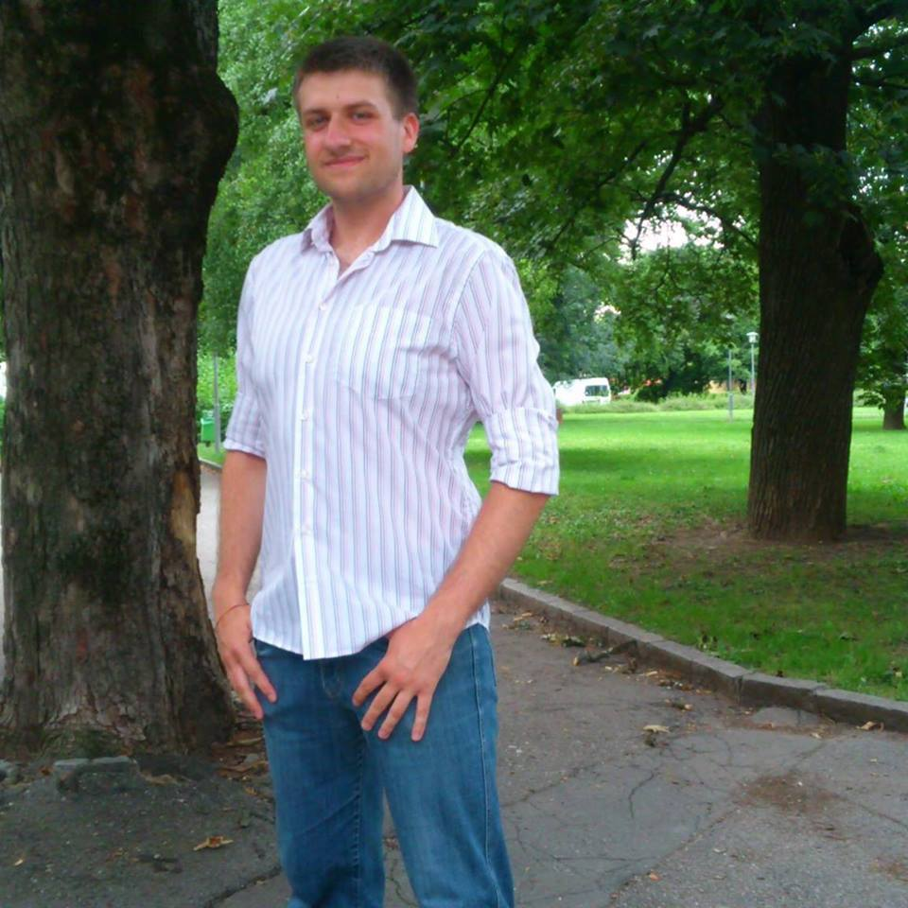

PARTNERS:
The project will host participants (each organisation will send 3 participants) from the following countries:

Bulgaria: OPEN SPACE FOUNDATION,
Italy: Mine vaganti NGO
Portugal: Associação Intercultural Amigos da Mobilidade
Greece: EURITI
Spain: ASOCIACION JUVENIL INTERCAMBIA
Croatia: Udruga gluhih i nagluhih Nova Gradiska

TRAVEL COSTS

According to new Erasmus Plus rules, the reimbursement of travel costs will be calculated used a specific program called Distance Calculator:

Country | Maximum amount refundable per
 | participant

Bulgaria | 275
Portugal | 275
Greece | 275
Spain | 275
Croatia | 275

After sending their tickets and boarding cards, participants will receive the reimbursement of
their travel costs once the hosting organization receive the first tranche of payment by Italian
national agency.
Food, accommodation and local transports for activities will be fully covered by the project.
Participation fee: the participant fee is 30 Euro per participant to be paid once arrived in Sardinia.

THE VENUE
The venue of the Project is Uri, Italian municipality of 3,040 inhabitants famous for its production of artichokes in the province of Sassari. It tis located about 18 km from Alghero and about 12 km northwest of Sassari and about 170 kilometres from Cagliari.
Province of Sassari is surrounded with famous turistic spots like Alghero, Stintino, Capo Caccia and Castelsardo.
Alghero and Olbia have airports which connect North Sardinia with many destinations in Italy and Europe. By boat: the nearest harbour are Porto Torres and Olbia.
For any inquiry, please contact us at following email address: minevaganti2010@gmai.com

HOW TO REACH URI
Alghero and Olbia have airports which connect North Sardinia with many destinations in Italy and Europe. By boat: the nearest harbour are Porto Torres and Olbia.
For any inquiry, please contact us at following email address: minevaganti2010@gmai.com

ARRIVAL
The organization will fix pick up point with the participants and will provide further information about the means of transportation between the airport of Alghero and Olbia and the venue.
Please note: to not purchase any tickets without receiving an official confirmation by email sent by Mine Vaganti NGO staff.

WHAT TO BRING?
Since there is going to be an international evening, we will ask you to bring something traditional, famous or delicious from home - that you would like to represent your country with, and share with the others, it can be any kinds of food, drink...

WEATHER
During March, weather in Uri is quite warm but it might be a bit colder. Nevertheless, in the evening it can be windy, so we suggest to bring jackets and some warm clothes, together with lighter items.

ACCOMMODATION
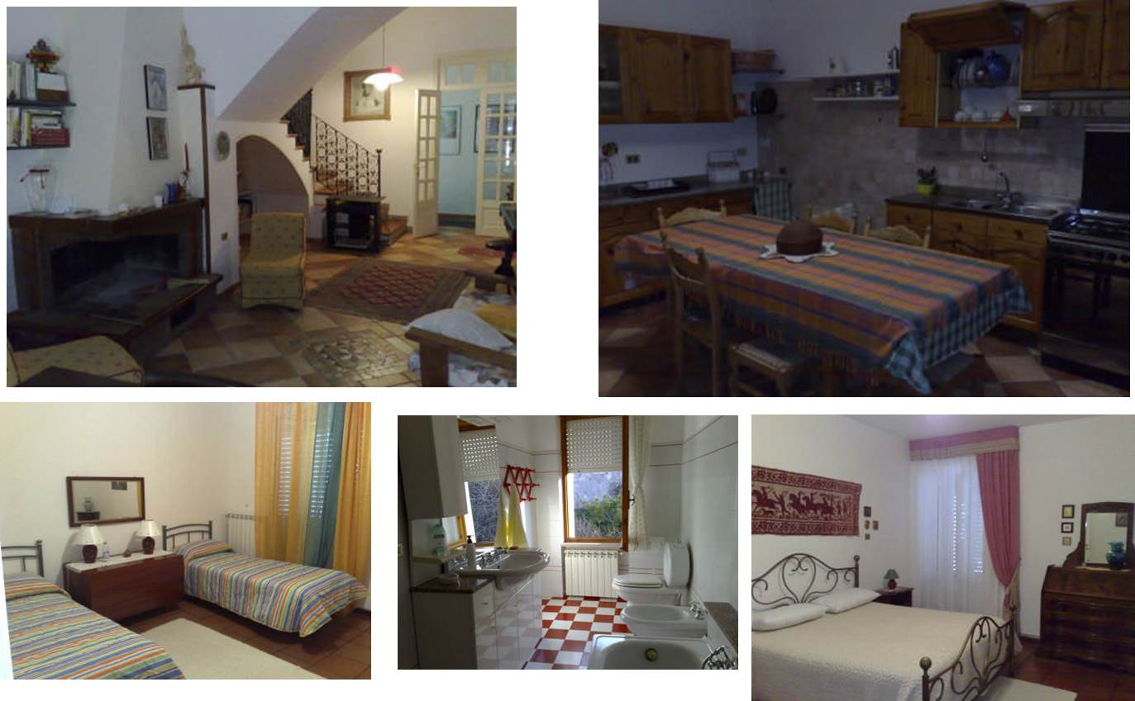
Participants will be accommodated in B&B La coronedda

ACTIVITIES ROOM
The activities will take place in Mine Vaganti NGO’s Office and Youth Centre in Uri, where several Erasmus+ Youth Projects already took place…..
…And Yes, there is WIFI there!

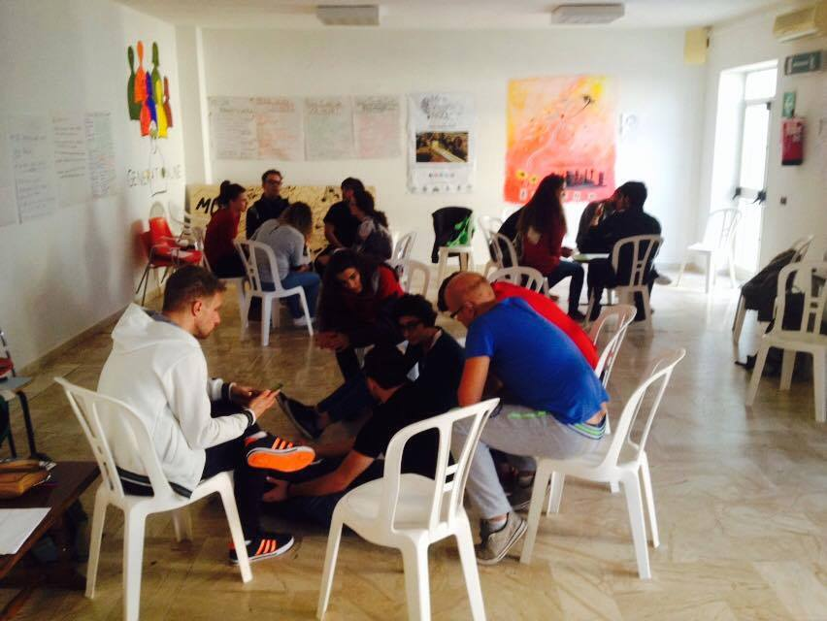

FOOD
We will eat at “Ristorante La Ciurma”, 500 meters far from activity room and B&B
Yes, Uri is very small!

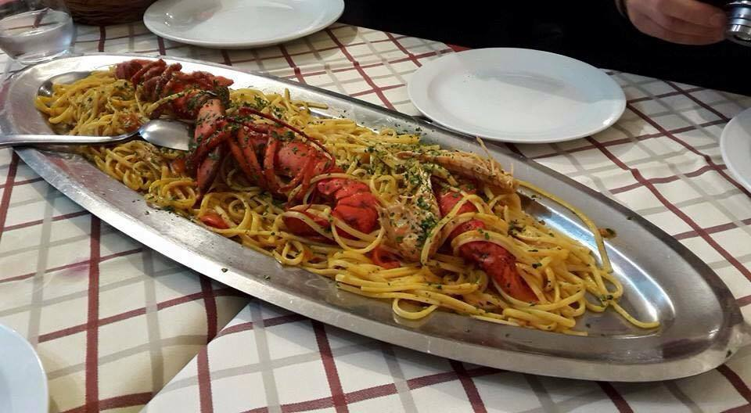

For further inquire, please contact:
Maria Grazia Pirina
Vicepresident Mine Vaganti NGO
Phone Number +39340757410 (Whatsapp)
Email: minevaganti2010@gmail.com
Skype: minevagantingo
