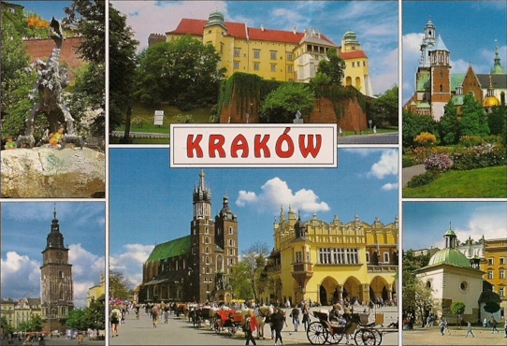
INFO – PACK

- ABOUT THE PROJECT
"Employ Yourself” is a 7-days training course dedicated to 27 people working every day in 9 non-governmental organizations on the field of social and educational activities for young people (especially unemployed youth) - social leaders, coordinators of volunteers, project managers, career counselors, facilitators, trainers and people who are close to the problems of young people on the labor market. The training course will be held in Cracow, Poland, 21-27.09.2016.
- WHO WE ARE
The Association Kulturatka (Stowarzyszenie Edukacji Nieformalnej Kulturatka) was founded in 2006 by young people interested in social integration and culture. The association was established to facilitate access to culture for young people and those for whom access to culture can be difficult for financial reasons. Group consists of young, open-minded people who are very happy to contribute to this discussion on the similarities and differences among young people in modern Europe. Our usual activities is: promotion of cultural events, writing and publishing articles on the website, organizing competitions for young people at risk of social exclusion, participation in cultural events, working with young people, teaching young people how to promote culture, how to work with cultural institutions, meetings with youngsters and discussing various matters associated with young people.
Most of us have organized or participated in international trainings and exchanges. We wish to share the knowledge and experiences with others to inspire each other, motivate to activities and development.
Project main staff:
Anna Salomea Kubica-Majka – facilitator: intercultural trainer, coach and facilitator specializing in training multinational teams and organizations that work on international projects. Coaches individuals who work and live in multicultural environments. During 10 years of cooperation with various NGOs, 5 of which spent in international environment, she delivered 600 hours of training in fields such as: team building, communication, strengths and weaknesses, multiculturalism, project management.
Graduated from the School of Trainers and The Art and Science of Coaching, completed supplementary trainings in intercultural competencies: Intercultural Conflict Style Inventory, Cultural Detective, Developing Intercultural Training Skills and others.
She publishes in The Institutions of Culture Handbook and the Polish Culture Managers Portal, focusing on the subject of innovative problem solving.
Fosters active relationships building with subject-matter experts in the field of intercultural relations for the SIETAR network – Society for Intercultural Education, Training and Research
Magdalena Skowrońska – project coordinator: Vice President of the Stowarzyszenie Edukacji Nieformalnej Kulturatka, Project Manager, trainer and facilitator. Specializes in the management of education and social projects financed by the EU. 4-year experience in this field. Since 2012 engaged in developing and implementing educational project for unemployed youth aiming to increase their professional competencies and employability. 200 hours of self-developing workshops dedicated to unemployed youth in region Malopolska. 6 years of experience in cooperation with NGOs in Poland. MA in Polish Philology, BA in Management, graduate the School Train the Trainer.
Agnieszka Skraburska – facilitator:
Accredited MATRIK Professional Management Trainer and Career Counsellor specializing in employability skills and career development trainings for students and graduates, as well as education and training programs for professionals working in the education sector.
Organizational Consultant and Executive Coach working in the systems-psychodynamic approach. She brings passion to her work to help people and teams develop and identify ways of realizing their potential. At the same time Aga also provides a safe environment for people to examine the possibilities of their development journey. She encourages people to explore how they operate in their organizations and lives, how they maximize their talents and skills, also helping them look where they operate less successfully and how they can handle this.
Project manager with over 10 years of experience in managing various international training and graduate recruitment projects for companies such as Airbus, Bahlsen, Capgemini, Shell, Toyota, Barclays Capital.
She offers services to individuals, groups, and organizations within the public, voluntary and private sectors.

- BASIC INFORMATION
"Employ Yourself” (date: 21-27.09.3016) is an 7 day course organized by Stowarzyszenie Edukacji Nieformalnej Kulturatka in cooperation with 8 partners from Estonia (Mittetulundusühing Youth Senate Tallinn), Greece (KYTTARO ENALLAKTIKON ANAZITISEON NEAON KEAN), Spain (Asociación Iniciativa Internacional Joven), Lithuania (ASOCIACIJA APKABINK EUROPA), Portugal (Associação Spin para o Intercâmbio, Formação e Cooperação entre os Povos), Romania (Asociatia Tinerilor Activi Civic), Turkey (Hayat Sende Genclik Akademisi Dernegi), Italy (Cooperativa Orso s.c.s).
The TC is set to engage social leaders, coordinators of volunteers, project managers, youth workers, career counselors, facilitators, trainers or people who are close to the problems of young people on the labor market and would like to strengthen their key competencies in order to improve the quality of work with unemployed youth, especially at risk of exclusion.
The main objective of the project is to improve competencies of 28 people in supporting young people in the area of coping in the labor market, in order to stimulate employability of young people and to create a space for the exchange of good practices in the area: entrepreneurship, job search and professional development, affecting the development of potential and improvement of the quality of systems supporting youth.
- PARTICIPANT PROFILE
Partner organizations have to choose 3 participants (1 woman and 2 men or 1 men and 2 women) who will take part in the TC. Participants should be:

- 3 active members of your organization
- people with the willingness of international work and cooperation, able to share know-how
- has a role of a social leader, coordinator of volunteers, project manager, career counselor, facilitator, trainer or person who is close to the problems of young people on the labor market
- works or would like to work directly with youth
- would like to develop knowledge and competences in the field of employability and share this knowledge with unemployed youth and help them in finding a job
- has good command of English
- there are no age limits.

- PARTICIPANT QUESTIONNAIRE
  - Till 2016-07-15 each participant has to fill in the questionnaire:
http://goo.gl/forms/SgigkQ0mx4wnqXz13
- WHAT TO PREPARE BEFORE YOU COME TO POLAND
We are inviting you to prepare several things along to make our training successful:
- Good attitude, optimism and willingness to cooperate.
- Any medication that you need.
- Very important! European Health Insurance cards or medical documents for treatment in Poland. We do not provide insurance for you.
- Some ideas and materials about your organization.
- Gather your know-how in a field of fighting unemployment and helping people to cope in the labor market (best practices from your organization in the field of practices and experiences in the field of employability and entrepreneurship).
- Examples of a game, exercise, energizer which we can use it during the meeting.
- A part of the Intercultural Night is getting to know a piece of your culture and cuisine. During the Intercultural Night each organization will have a space to express some of your culture: you can prepare a performance, a dance, you can sing a song, recite a poem or a game which is characteristic for you country. If it is possible bring a flag, any national costumes you have. For activities you prepare you need to involve other participants. Please bring with you some specifics dishes from your country. Preferably those that don’t require any kind of cooking to be served.
- ARRIVALS
- The training starts on 21.09.2016 and finishes on 27.09.2016, however in project there are planned extra days for travelling it means that the accommodation for this days will be provided by us. Each organization can spend extra days to visit Krakow or just to rest after of before the journey.
Estonia – arrival 21.09.2016 departure 28.09.2016 (1 day of travel)
Greece – arrival 21.09.2016 departure 28.09.2016 (1 day of travel)
Spain – arrival 20.09.2016 departure 28.09.2016 (2 days of travel)
Lithuania – arrival 21.09.2016 departure 28.09.2016 (1 day of travel)
Portugal – arrival 20.09.2016 departure 28.09.2016 (2 days of travel)
Romania – arrival 21.09.2016 departure 28.09.2016 (1 day of travel)
Turkey – arrival 20.09.2016 departure 28.09.2016 (2 days of travel)
Italy – arrival 21.09.2016 departure 28.09.2016 (1 day of travel)

- FLIGHTS & REIMBURSEMENT
The project cover expenses related to accommodation, food and travel expenses.
The reimbursement of travel costs will be made according to the rules of Erasmus + Programme and according to the distance calculator: http://ec.europa.eu/programmes/erasmus-plus/resources_en#tab-1-4
Please before you buy tickets, check the distance between starting point to Krakow. If the distance is less than it was previously calculated in the budget, it may happen that you will receive less of the reimbursement.
- Travel cost will be refund when you give us all original tickets, boarding passes, confirmation of payment. In our budget there is a maximum cost that you can get back for your travel. It may happen that your tickets will be more expensive than the amount in the budget in that case we will refund you back the amount according the estimation below.
Example 1:
You are form Italy and you paid for your travel 200 euro. You will get back 200 euro.
Example 2:
You are form Italy and you paid for your travel 300 euro. You will get back 275 euro.

 | Partner organization from: | Maximum of travel cost (euro), both way, per 1 participant | Distance for calculation – one way
1 | Estonia | 275 euro | 500 km – 1 999 km
2 | Greece | 275 euro | 500 km – 1 999 km
3 | Spain | 360 euro | 2000 km – 2 999 km
4 | Lithuania | 275 euro | 500 km – 1 999 km
5 | Portugal | 360 euro | 2000 km – 2 999 km
6 | Romania | 275 euro | 500 km – 1 999 km
7 | Turkey | 360 euro | 2000 km – 2 999 km
8 | Italy | 275 euro | 500 km – 1 999 km

- The refund of travel costs will be made by bank transfer after you come back to your city from the training course and send all original travel tickets to us.
- Please collect all your original travel tickets (plane tickets and boarding passes, train, bus tickets etc.) and confirmation of payment for tickets (print from your bank account system) and send it back in one package by post (post address: Magdalena Skowronska, ul. Do Wilgi 20/27, 30-419 Krakow, Poland) as soon as you come back home, but no later than on 31.10.2016.
- IMPORTANT: refund for travel will be made to your leader or organization bank account. To avid costs of international transfer we will make one bank transfer per one organization.
- To receive reimbursement of travel expenses you must deliver to us documents as follow:
- originals of all tickets and boarding passes (from each person, and both way direction)
- confirmation of payment for tickets (print from your bank account system)
- bank account details to which we will make a reimbursement (like: name of the bank, address).
- We will refund your travel expenses no later than 30 days from the date we receive the required documents. We will transfer money to the bank account number which you gave to us. Transfer will be made in EURO.
- Association KULTURATKA will also cover the costs of the bank transfer.
- If you have any questions related to the reimbursement, plane, train tickets, please contact me.

- TRAVEL INFORMATION
- Delegations that arrive to KRAKÓW (Krakow Balice Airport)
After landing in the Krakow Airport you have to take the bus No. 292 or 208 and get off at the DWORZEC GŁÓWNY WSCHÓD bus station. These are AGGLOMERATION BUS LINES.
The bus stop is situated very close to the airport. When you exit the airport, the bus stop will be about 100 meters away.
Direction: Dworzec Główny Wschód
Stop to get on: Balice Airport T1
Stop to get off: Dworzec Główny Wschód
Agglomeration ticket price – 4,00 PLN. The journey takes about 40 minutes. You can buy 60-minutes ticket for 5,00 PLN and it will let you to travel from the airport to the central station and from central station to the Hostel (that kind of ticket entitles to an unlimited number of journeys for a period not exceeding time specified on the ticket from its validation or entitling to a single journey to a stop or station which is the last on the route).
Tickets can be purchased from the RELAY newsagents shop – T1 international terminal, mezzanine or the ticket machine at the bus stop or inside the bus. To buy tickets on the ticket machine you need coins as the ticket machine doesn’t take notes.
More information about airport transport and schedule of buses you will find here:
http://www.krakowairport.pl/en/passenger,c70/transport-parking,c76/how-to-get-to-krakow-airport,c77/by-public-bus,a198.html
You can also take a train from Krakow Balice Airport. The price is 8,00 PLN. More information you will find here: http://www.malopolskiekoleje.pl/index.php/routes/krakow-airport-krakow-main-railway-station
Later, when the accommodation will be arranged, I will send you details about how to get to the hotel/hostel.
- Delegations that arrive to WARSZAWA (Warsaw Airport)
After landing in the Warsaw Airport you must take the bus No. 175 to get to the DWORZEC CENTRALNY bus station.
Ticket price is 4,60 PLN. The journey takes about 25 minutes.
After getting to the Dworzec Centralny bus station you have to take train to KRAKÓW GŁÓWNY train station. This are selected trains, if you need more, please contact me individually.

WARSZAWA CENTRALNA – KRAKÓW GŁÓWNY (train stadion)
Departure time
07:55 – 10:14 (travel time is about 2,20 hours, ticket price from 135,00 PLN Economy class).
09:00 – 11:28 (travel time is about 2,20 hours, ticket price from 135,00 PLN Economy class).
09:50 – 12:11 (travel time is about 2,20 hours, ticket price from 135,00 PLN Economy class).
11:10 – 13:40 (travel time is about 2,30 hours, ticket price from 49,00 PLN Economy class).
12:50 – 15:09 (travel time is about 2,20 hours, ticket price from 135,00 PLN Economy class).
14:55 – 17:50 (travel time is about 2,20 hours, ticket price from 135,00 PLN Economy class).

More information you will find here: http://www.intercity.pl/en/site/forpassengers/information/journey-planner.html
Please note that we cover journey expenses only in economy class.

- ACCOMMODATION
Accommodation is provided during the information stated in VI. Arrivals. There will be double, triple and quad rooms in hotel/hostel in Krakow. At the moment I am searching for good place for the participants. I will let you know where you sleep no later but one month before training.

- TRAINING PLACE and MEALS
Training will take place in Krakow. The name of the training place will be given no later but one month before training. During the training we will provide meals: breakfast, lunch and dinner.

- OTHER INFORMATION
Currency – Polish zloty (PLN). Money can be exchanged in the exchange office at the airport or in the city center.
Temperature: weather in September in Poland is quite good. At night it might be chill (10 degrees) during the day the temperature will be oscillating between 18 and 25 degrees.
Please bring some warm clothes and an umbrella or raincoat (just in case it rains).
Emergency number in Poland: 112

- MORE INFORMATION ABOUT THE ERASMUS +
http://ec.europa.eu/programmes/erasmus-plus/index_en.htm

The password of this training is “Wawel”. After reading this message, please send me the password in e-mail till 15th of June, so that I know you have understood all the instructions and tasks.
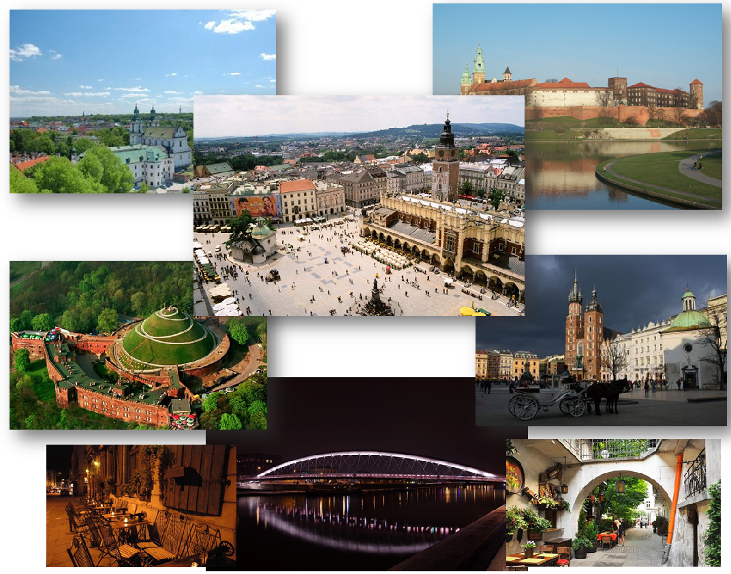
We are looking forward to working together with you!
Do not hesitate to contact us if you have any questions!

Best regards,
Magdalena Skowrońska
Project Coordinator
Association KULTURATKA
e-mail: m.skowronska@kulturatka.pl
Contact mobile phone number during the project: 0048 793 618 693.

