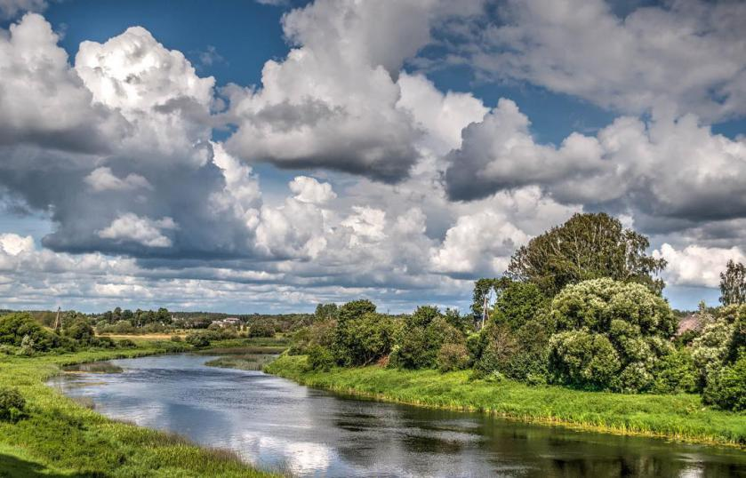
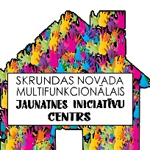
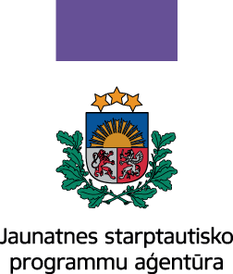
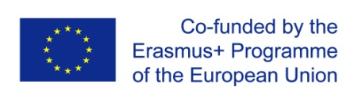
Open Call for EVS Volunteers.
For whom: EVS volunteers who want to spend an exciting year in a small rural town in Latvia working at the Skrunda multifunctional youth initiative centre and being part of the local community.
Where: Latvia, Skrunda. A beautiful rural town on the banks of river Venta.
When: from April/May 2019.
How long: 12 months
Organisation: Skrunda Multifunctional Youth Initiative Centre together with Radi Vidi Pats (Liepāja).
Skrunda Multifunctional Youth Initiative Centre is a place where young people from Skrunda Municipality can spend their free time – socialising, learning, planning and organising their initiatives or simply having fun and creative time.
We would like the local youth to learn about different cultures and to bring a “breeze of fresh air” at the centre. So we are looking for creative, active volunteers who are willing to work with young people, to organise various activities within the centre and local community.
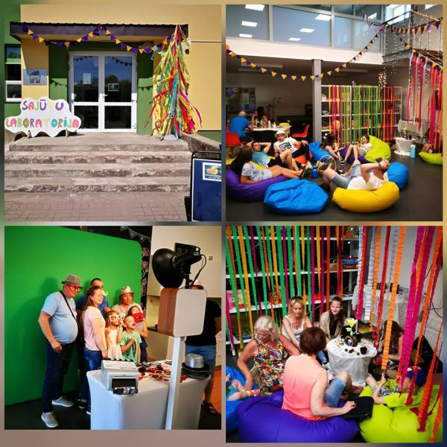
Here are just some of the activities that you could be involved in:
- planning day to day activities at the Youth centre
- organizing events and workshops at the centre and within the local community (language studies, art classes, cooking workshops, sports events etc.
- Daily tasks will include planning events and preparation for the events and workshops, daily youth centre activities such as discussions with the youth, playing board games etc.
- walks, camping trips and outdoor sports events
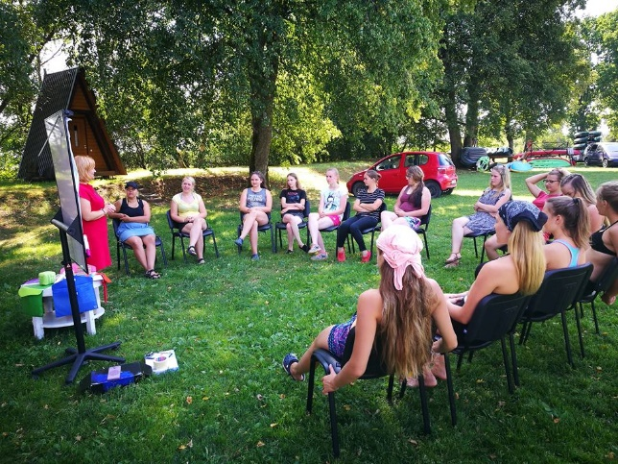
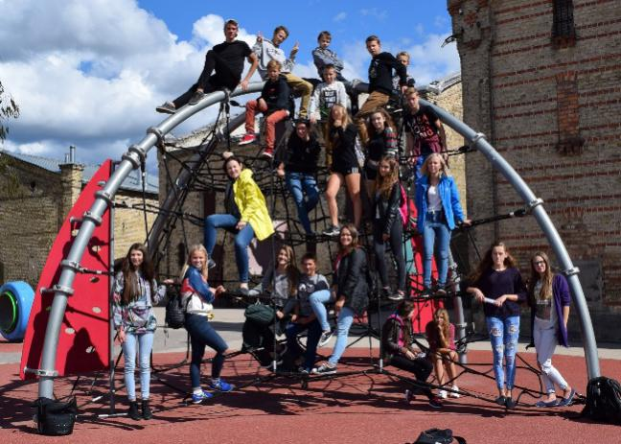

There are plenty of things to do in Skrunda – great walking and cycling routes, regular sports events (Skrunda is famous for its volleyball players), concerts and plays. You can also join the local drama club or one of the folk dance groups – there will definitely be something to everyone’s taste!

Latvia is such a beautiful country with so many amazing places to see. Skrunda is conveniently located near the A9 so it will be easy for the volunteers to travel around by public transport.
Visit Liepaja (65 km) with its amazing beach, Kuldiga (35km) with the widest waterfall in Europe or the capital of Latvia (150 km
But there are plenty of lovely places to see in and around Skrunda - come and see for yourself!
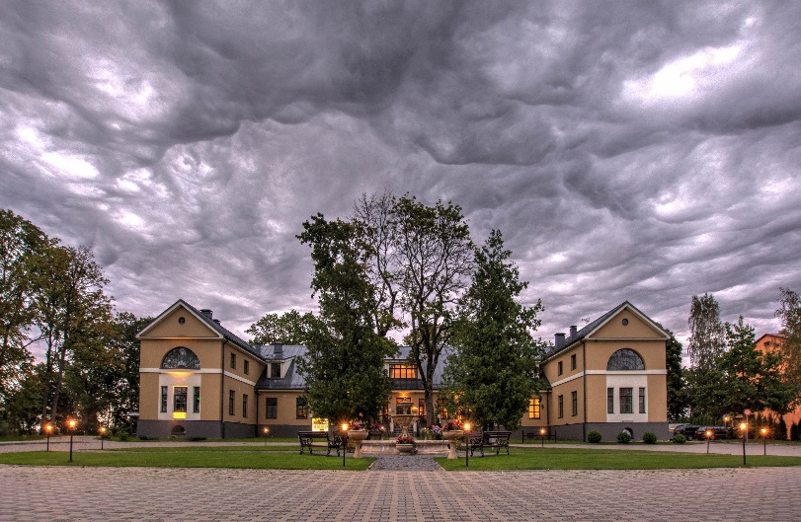
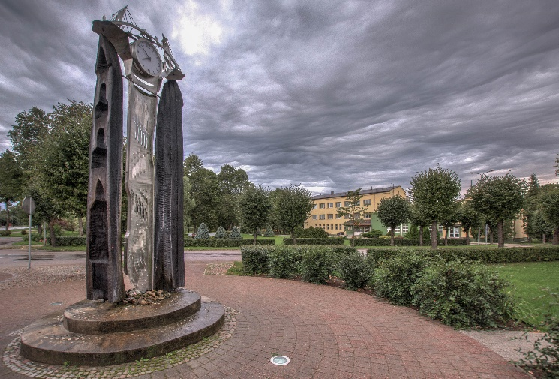

Contacts: Baiba Eversone
baiba.eversone@skrunda.lv
Links:
https://www.facebook.com/skrundasjauniesucentrs/
http://www.skrunda.lv/lv/

